Release Note

Reopen Finished Prod. Order

# 1 Basic Details

|  |  |
| --- | --- |
| Customer |  |
| Customer Name | N/A |
| Customer PM  (Where appropriate) | N/A |

|  |  |
| --- | --- |
| Release Control |  |
| Reference No. | MA003 |
| Author | Marcus Ambra |
| Release | 2004-01R |
| Risk Level | Low |
| Release Date | 16/04/2020 |
| Release Media | FOB |
| Release Reason |  |
| Database Version | Dynamics NAV 2018 (11.0.24742) |
| Package Name | NA |
| Delivery Method | NA |
| Customer Approval  (Delivery) | NA |

|  |  |
| --- | --- |
| Work Detail |  |
| Project Name | Reopen Finished Prod. Order |
| Project Manager | NA |
| Project Phase | Project |
| Person (Developer/Consultant) | Marcus Ambra |
| Functional Area | Manufacturing |
| Reviewer/Approver (Peer/Senior) |  |
| Design Reference | NA |
| Development Release note no. | NA |

# 2 Overview

Production Order 1011001 is currently finished

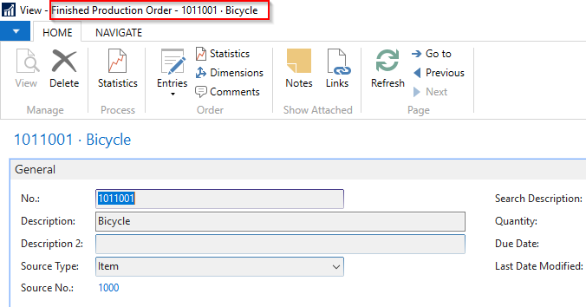

The production manager should post 270 minutes of operation 100 (Wheel Assemble).

As you can see below there are 100 minutes missing to be posted:

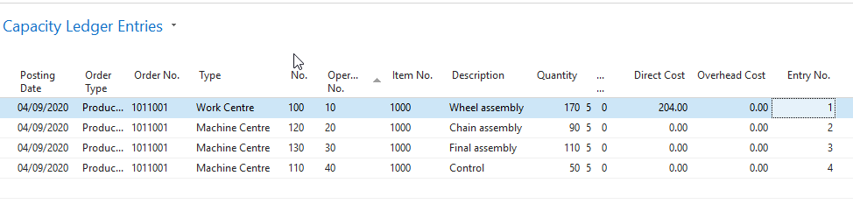

1. The production manager decided to re-open the production order and post the missing labor time:

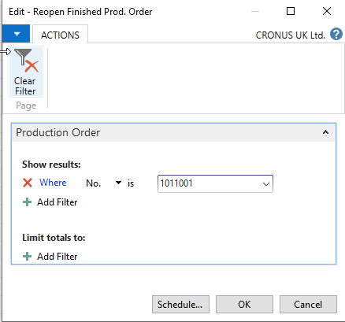

The production order in now Released and ready to be used:

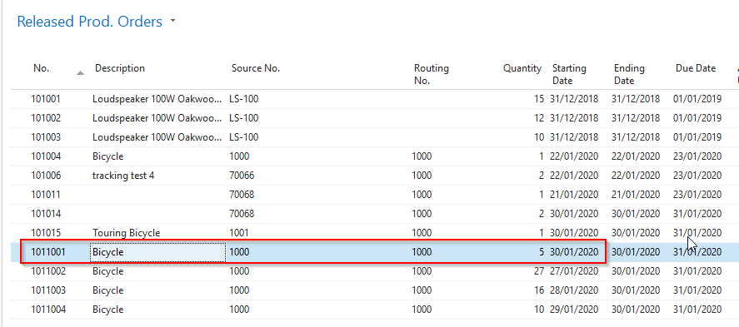

1. Production Manager has posted the missing 100 minutes of the operation Wheel Assembly.

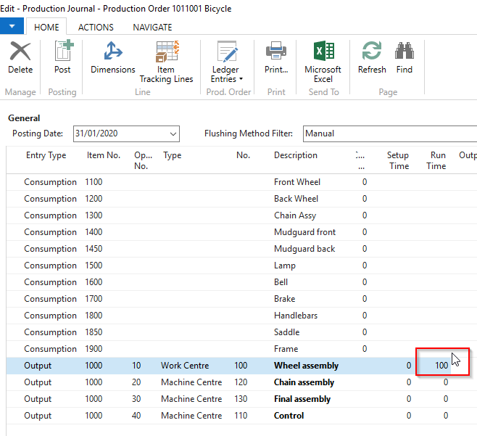

1. The Production Order status has been changed to Finished
2. Run the report ADJUST COST – ITEM ENTRIES

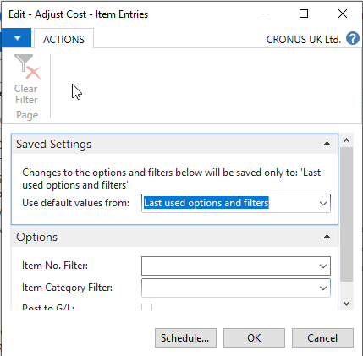

1. Run the report POST INVENTORY COST TO GL

As you can see below, the missing 100 minutes has been properly assigned to the item

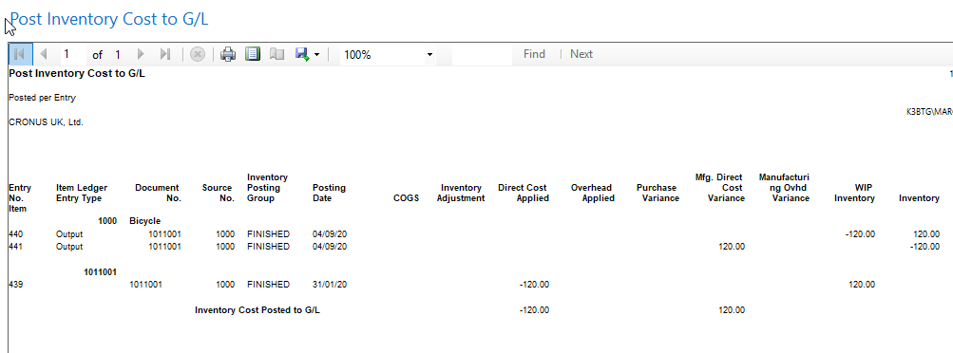

# 3 Technical Details

## 3.1 Summary of Solution Modifications

I have created a bespoke report which is used to reopen a finished production order.

### 3.1.1 Modifications

The following new modifications have been completed and tested:

|  |  |  |  |
| --- | --- | --- | --- |
| Reference | Source | Type | Summary |
|  |  |  |  |

## 3.2 Object Changes

**Important Note**: If there is any discrepancy between the Original Object details and the corresponding Object Details in your database, please do not import them, but inform immediately with details.

### 3.2.1 Object Verification

|  |  |
| --- | --- |
| Source database object changes were developed in |  |
| Date development objects compared to live | 16/04/2020 |

### 3.2.2 Existing

|  |  |  |  |  |  |  |
| --- | --- | --- | --- | --- | --- | --- |
| Object Type (table, form, etc.) | Object ID | Name | Modified | Version | Date | Time |
|  |  |  |  |  |  |  |

### 3.2.3 New

|  |  |  |  |  |  |  |
| --- | --- | --- | --- | --- | --- | --- |
| Object Type (table, form, etc.) | Object ID | Name | Modified | Version | Date | Time |
|  |  |  |  |  |  |  |



## 4. Post Deployment Testing Steps

Please ensure your testing is proportionate to the level of risk.

### 4.1 To Test Code

### 4.2 To Test Data Fix

Not required

# 5 Quality Assurance

## 5.1 Testing Completed

NA

## 5.2 Code Review / Testing

|  |  |  |
| --- | --- | --- |
|  | Name | Date completed |
| Unit Test completed by | Marcus Ambra | 16/04/2020 |
| Code Review completed by | Marcus Ambra | 16/04/2020 |
| Testing completed by | Marcus Ambra | 16/04/2020 |
| UAT testing completed successfully | Marcus Ambra | 16/04/2020 |

# 6 Sign Off

|  |  |  |  |
| --- | --- | --- | --- |
| Action | Name | Signature | Remarks |
| Released By | Marcus Ambra | Marcus Ambra |  |
| Approved By |  |  |  |

All objects/changes moved in to your live environment by yourself or otherwise, are considered complete and approved. Any further changes required after this stage may be considered a new change request.

Please be aware that objects/changes not moved into your live environment within a reasonable amount of time, upon completed user acceptance testing, may cause conflict with other objects/changes.